**Object-Oriented Analysis and Design Project**

**Coffee shop**

**Submitted by**

Mr.Chawit Sommana 582115014

Mr.Thanarit Lopetcharat 582115026

Mr.Phornthep Chooleat 582115037

Mr.Pattaratorn Sawaisorn 582115039

**Present**

Prof. Prompong Sugunnasil

**953232 Object-Oriented Analysis and Design**

**College of Art Media and Technolog**

**April 27, 2017**

**Introduction**

Nowadays, Coffee Shop business is increasing popular in Thailand. Because the product in the Coffee Shop is suitable for any kind of the customer. And the Coffee Shop is the multi purposes place for the customer; for example the meeting, reading place, surfing the internet and etc.

So, all of this is the reason that we chose to do this project. For according to this course, so we want to create and design the management system by using the diagram for explain the step of management the Coffee Shop to convenience of the managing in Coffee Shop. Moreover, to practice the planning and design the management system to performance and can lead to utilization in real life in the future.

**Target**

Coffee Shop Owner of Coffee Shop Employee who would like to be an own Coffee Shop and need planning and design to manage the production of Coffee Shop. And for the convenience to production for sale in the Coffee Shop.

**Benefits**

1. For the convenience to production for sale in the Coffee Shop.
2. For performance to planning and design of management system store.
3. For analyzing the step of management system in Coffee Shop to efficiency.
4. To practice the planning and design the management system according to the course.
5. To understand how to use and design the diagram to explain the plan of management in the Coffee Shop.

**Table Content**

**Page**

**Introduction I**

**Table Content II**

**Overall Description 1**

**Specific Requirement 3**

* Use Case Diagram **3**
* Use case description **4**
* Activity diagram **22**
* Class diagram **38**
* Class description  **39**
* Sequence diagram **53**

**Overall Description**

In our management system of Coffee Shop. We have 3 main actors are Owner, Cashier and Barista. And everyone need to login to the system before use the system.

**Owner part:**

1.Can view summary to see the overall product that have been sold.

2. Can add new cashier to the system.

3. Can add new barista to the system.

4. Can delete cashier from system.

5. Can delete barista from system.

6. Add new product to the system.

7. Can delete product from system.

**Cashier part:**

1. Take order from customer and request to barista when customer want to order the goods.

2. Manage in the payment part when customer request cashier to pay a bill.

3. Manage in the print invoice part when customer request the invoice from cashier.

4. Can view the ordered list and status in the system.

5. Print the ordered id from the system to customer when barista has confirmed requesting order from user.

6. Can delete order from requesting order.

**Barista part:**

1. Manage in the confirm order part when customer requesting menu and then barista will confirm that can do or not.

2. Confirm that order is already finish.

3. Can view the ordered list and status in the system.

All the tasks, everyone can cancel the tasks that they are doing and back to main menu or finish the program.

**Specific Requirement**

**Use Case Diagram**

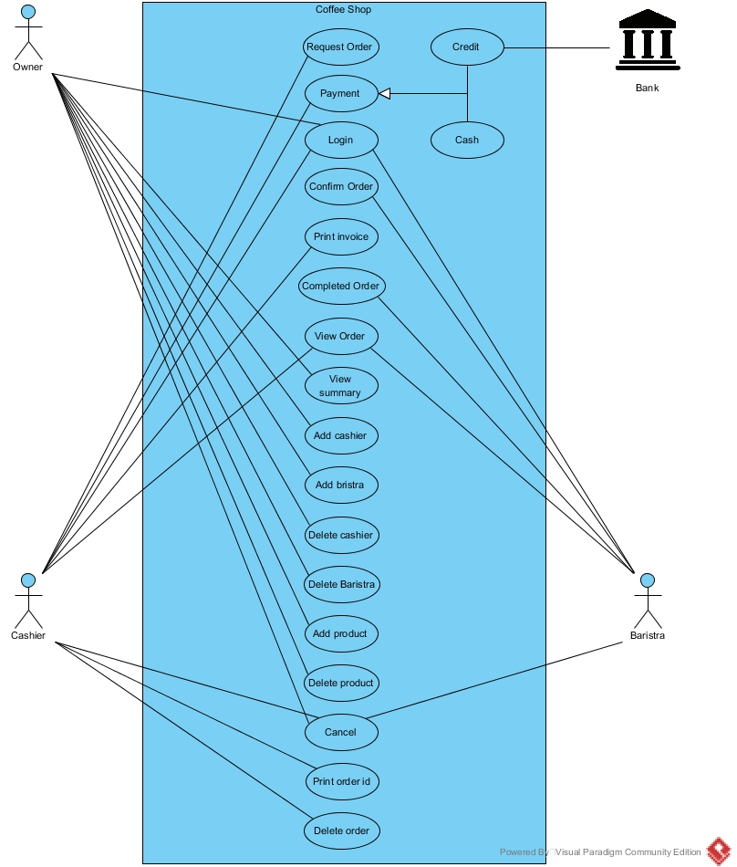

**Use case description**

US-001 Request Order

|  |  |  |  |  |
| --- | --- | --- | --- | --- |
| Use Case ID | US-001 | | | |
| Use Case Name | Request order. | | | |
| Created By | Phornthep Chooleat | | Last Update By | Phornthep Chooleat |
| Date Created | 22/04/2017 | | Last Revision Date | 24/04/2017 |
| Actors | Cashier. | | | |
| Description | Cashier take order from customer and request to barista. | | | |
| Trigger | Customer want to order the goods. | | | |
| Preconditions | User mush to logged in the system. | | | |
| Use Case Input Specification | | | | |
| Input | type | Constraint | | Example |
| productId | String | Using 2 character of alphabetic and 2 digit of numerical. | | Sm01, Co04. |
| Post conditions | Send order information to barista. | | | |
| Normal Flows | User | | System | |
|  | 1. User select the Request order in main menu. 2. User click add order. 3. User input the order from customer to the system. | | 1. System provide Order requesting page to the user. 2. System check the input. 3. Change order status to requesting order. 4. System send the data to barista. | |
| Alternative Flow | 1. In activity 5 of Normal flow, if user input incorrect pattern of input system will provide “Wrong input please input it again.” And back to activity 2 of Normal flow. | | | |
| Exception Flow | User press the cancel button. | | | |
| Assumption | 1. User understand English. 2. User understand the customer order. | | | |

US-002 Payment

|  |  |  |  |  |
| --- | --- | --- | --- | --- |
| Use Case ID | US-002 | | | |
| Use Case Name | Payment | | | |
| Created By | Phornthep Chooleat | | Last Update By | Phornthep Chooleat |
| Date Created | 22/04/2017 | | Last Revision Date | 25/04/2017 |
| Actors | Cashier. | | | |
| Description | Customer request cashier to pay a bill. | | | |
| Trigger | User select Payment button. | | | |
| Preconditions | 1. User mush logged in into the system. 2. Customer want to pay a bill. | | | |
| Use Case Input Specification | | | | |
| Input | type | Constraint | | Example |
| orderId | int | Numerical of 3 digit. | | 001 |
| amountOfMoney | double | Numerical more than 4 digit and less than 7 digit. (Including faction number) | | 200.00 |
| Post conditions | 1. System record the transaction into the database and delete order id in the requesting order. 2. System provide print invoice page to user. | | | |
| Normal Flows | User | | System | |
|  | 1. User select payment button in the menu. 2. User in put order id to the system. 3. User select confirm payment. 4. User select payment method as cash. 5. User input amount of money received from customer.   18.User select confirm. | | 1. System request order id from user. 2. System check the order id that received from user. 3. System show amount of value to the user. 4. Provide confirm payment page to user. 5. System request type of payment (credit, cash) from user. 6. System request amount of money from user. 7. System check the input. 8. System calculate the change. 9. System show amount of change to user. 10. System open the money tray. 11. System provide receive money page to user. 12. System ask the user to close the money tray.   19.System close the money tray.  20.System record the transaction to the data base.  21.System provide print invoice   page to user. | |
| Alternative Flow | 1. In the activity 4 of Normal flow, if user input wrong order id system will provide “Wrong id or not have this id in the system” Message to user and system back to the activity 2 in Normal flow. 2. In the activity 7 of Normal flow, if user do not confirm system will provide the main menu page to user. 3. In the activity 12 of Normal flow, if user input incorrect input system will provide “Wrong input please input it again.” Message to user and system back to the activity 10 in Normal flow. 4. In the activity 18 of Normal flow, if user do not confirm after 3-minute system will provide “Automatically close money tray because money tray had opened more than 3-minute.” Message to user and system ask user to login to open the money again. 5. In the activity 9 of Normal flow, if user select payment method as credit system will provide credit payment to user.    1. System request credit card from user.    2. User input the credit card to credit card machine.    3. System Check the permission from the bank.    4. System subtract amount of bill in the credit card.    5. System print receipt to the user.    6. System do the activity 20 in the Normal flow. 6. In the activity 6.3. of Alternative flow, if the bank does not allow system to do the payment system provide “Can’t pay by credit card please use another payment method.” Message to user and back to the activity 7 in the Normal flow. | | | |
| Exception Flow | User press the cancel button. | | | |
| Assumption | 1. User understand English. 2. Cashier machine have change for user. | | | |

US-003 Login

|  |  |  |  |  |
| --- | --- | --- | --- | --- |
| Use Case ID | US-003 | | | |
| Use Case Name | Login | | | |
| Created By | Phornthep Chooleat | | Last Update By | Phornthep Chooleat |
| Date Created | 23/04/2017 | | Last Revision Date | 25/04/2017 |
| Actors | Owner, Cashier and Barista. | | | |
| Description | Login to the system to use the system. | | | |
| Trigger | User click login button. | | | |
| Preconditions | 1. User want to use the system. 2. User have user id and password. | | | |
| Use Case Input Specification | | | | |
| Input | type | Constraint | | Example |
| userId | String | Using of 3 character and 2 of numerical without any symbols. | | Bar01, Cas01. |
| userPass | String | Using both of alphabetic and numerical of 5 character. | | ase34, b23ed. |
| Post conditions | 1. User logged in to the system. 2. System provide main menu page to user. | | | |
| Normal Flows | User | | System | |
|  | 1. User select login button. 2. User in put user id and password. | | 1. System provide login page to user. 2. System check the input. 3. System check the data in the database. 4. System provide main menu page to user. | |
| Alternative Flow | 1. In the activity 4 of Normal flow, if the input is incorrect pattern of input system provide “Wrong input, please input it again.” And back to the activity 2 of Normal flow. 2. In the activity 5 of Normal flow, if the user id is not the same the data in the database system provide “Not have this user id in the database please input it again.” And back to the activity 2 of Normal flow. 3. In the activity 5 of Normal flow, if the user id is the same the data in the database but the password is not the same system provide “Incorrect password please input it again.” And back to the activity 2 of Normal flow. | | | |
| Exception Flow | User press the cancel button. | | | |
| Assumption | 1. User understand English. 2. User have user is and password. 3. User want to use the system. | | | |

US-004 Confirm order

|  |  |  |  |
| --- | --- | --- | --- |
| Use Case ID | US-004 | | |
| Use Case Name | Confirm Order | | |
| Created By | Phornthep Chooleat | Last Update By | Phornthep Chooleat |
| Date Created | 23/04/2017 | Last Revision Date | 25/04/2017 |
| Actors | Barista. | | |
| Description | Barista confirm that they can do the requesting order. | | |
| Trigger | System show the requesting order to user. (At least one requesting order in the system) | | |
| Preconditions | 1. System have requesting order from the cashier. 2. Barista select view requesting order. 3. User mush logged in into the system. | | |
| Use Case Input Specification | | | |
| Post conditions | System send the confirmation to cashier. | | |
| Normal Flows | User | System | |
|  | 1. Select confirm order in requesting order. | 1. System change order status to doing order. 2. System send the confirmation data to cashier. | |
| Alternative Flow | 1. In the activity 1 of Normal flow, if user select cancel order.    1. System will ask user to confirm cancel request.    2. User select confirm cancel request.    3. System delete that requesting order in requesting order list.    4. System send the data to cashier.    5. System provide requesting order page to user. 2. In the activity 1.2. of alternative flow, if user select cancel to cancel request.    1. System provide requesting order to the user. | | |
| Exception Flow | User press the cancel button. | | |
| Assumption | 1. There is at least one requesting order in the system. 2. User understand English. | | |

US-005 Print invoice

|  |  |  |  |  |  |
| --- | --- | --- | --- | --- | --- |
| Use Case ID | US-005 | | | | |
| Use Case Name | Print invoice | | | | |
| Created By | Phornthep Chooleat | | Last Update By | Phornthep Chooleat | |
| Date Created | 25/04/2017 | | Last Revision Date | 25/04/2017 | |
| Actors | Cashier. | | | | |
| Description | User print the invoice from the system to customer. | | | | |
| Trigger | 1. Customer request the invoice from user. 2. User select print invoice. | | | | |
| Preconditions | 1. User need to do the payment method before. 2. User mush logged in into the system. 3. Payment method have successful. | | | | |
| Use Case Input Specification | | | | | |
| Input | type | Constraint | | | Example |
| orderId | int | Numerical of 3 digit. | | | 003 |
| Post conditions | System print the invoice for user. | | | | |
| Normal Flows | User | | System | | |
|  | 1. User select print invoice. 2. User input order id. 3. User select confirm. | | 1. System provide print invoice page to user. 2. System check input from user. 3. System ask to confirm print invoice. 4. System print invoice to user. 5. System provide main menu page to user. | | |
| Alternative Flow | 1. In activity 4 of Normal flow, if user input incorrect input system will provide “Wrong input please input again.” And back to the activity 2 of Normal flow. 2. In activity 6 of Normal flow, if user do not select confirm print invoice system will provide main menu page to user. | | | | |
| Exception Flow | User press the cancel button. | | | | |
| Assumption | 1. User understand English. 2. Customer want the invoice. 3. There is the invoice paper in the cashier machine. | | | | |

US-006 Complete Order

|  |  |  |  |
| --- | --- | --- | --- |
| Use Case ID | US-006 | | |
| Use Case Name | Complete order | | |
| Created By | Phornthep Chooleat | Last Update By | Phornthep Chooleat |
| Date Created | 25/04/2017 | Last Revision Date |  |
| Actors | Barista. | | |
| Description | Barista confirm that order is already finish. | | |
| Trigger | User want to confirm the preparing order have finish. | | |
| Preconditions | 1. User click view order. 2. User click complete product. 3. User mush logged in into the system. | | |
| Use Case Input Specification | | | |
| Post conditions | System send to data to cashier. | | |
| Normal Flows | User | System | |
|  | 1. User select complete order. 2. User select confirm. | 1. System ask the confirmation from user. 2. System change order status to completed. 3. System send data to cashier 4. System provide main menu page to user. | |
| Alternative Flow | 1. In activity 3 of Normal flow, if user do not select confirm system will provide view order page to user. | | |
| Exception Flow | User press the cancel button. | | |
| Assumption | 1. User understand English. 2. Order have finished. 3. There is one of finish order. | | |

US-007 View Order

|  |  |  |  |
| --- | --- | --- | --- |
| Use Case ID | US-007 | | |
| Use Case Name | View order | | |
| Created By | Phornthep Chooleat | Last Update By | Phornthep Chooleat |
| Date Created | 25/04/2017 | Last Revision Date |  |
| Actors | Barista, Cashier. | | |
| Description | To see the ordered list and status in the system. | | |
| Trigger | User click on view order button. | | |
| Preconditions | 1. User click view order. 2. User mush logged in into the system. | | |
| Use Case Input Specification | | | |
| Post conditions | System show the ordered list in the system. | | |
| Normal Flows | User | System | |
|  | 1. User select view order. | 1. System provide view order page to user. | |
| Alternative Flow | - | | |
| Exception Flow | User press the cancel button. | | |
| Assumption | 1. User understand English. 2. User want to see ordered list in the system. | | |

US-008 View Summary

|  |  |  |  |
| --- | --- | --- | --- |
| Use Case ID | US-008 | | |
| Use Case Name | View Summary | | |
| Created By | Phornthep Chooleat | Last Update By | Phornthep Chooleat |
| Date Created | 25/04/2017 | Last Revision Date |  |
| Actors | Owner. | | |
| Description | To see the overall product that have been sold. | | |
| Trigger | User click on view summary button. | | |
| Preconditions | 1. User click view summary. 2. User mush logged in into the system. | | |
| Use Case Input Specification | | | |
| Post conditions | System show the overall sold product in the system. | | |
| Normal Flows | User | System | |
|  | 1. User select view summary. | 1. System provide view summary page to user. | |
| Alternative Flow | - | | |
| Exception Flow | User press the cancel button. | | |
| Assumption | 1. User understand English. 2. User want to see overall sold product in the system. | | |

US-009 Add Cashier

|  |  |  |  |  |  |
| --- | --- | --- | --- | --- | --- |
| Use Case ID | US-009 | | | | |
| Use Case Name | Add cashier | | | | |
| Created By | Phornthep Chooleat | | Last Update By | Phornthep Chooleat | |
| Date Created | 25/04/2017 | | Last Revision Date |  | |
| Actors | Owner. | | | | |
| Description | Add new cashier to the system. | | | | |
| Trigger | 1. User click on Add cashier button. | | | | |
| Preconditions | 1. User mush login to the system. | | | | |
| Use Case Input Specification | | | | | |
| Input | type | Constraint | | | Example |
| userName | String | Using alphabetic more than 1 character but less than 255 character without symbols. | | | Phornthep |
| userTel | String | Using of numerical of 10 digit. | | | 0954511818 |
| Post conditions | 1. System add new user into the system. 2. System provide user id and user password to user. | | | | |
| Normal Flows | User | | System | | |
|  | 1. User select add cashier. 2. User input user name 3. User input user telephone number. 4. User select confirm. 5. User select print user id and password. | | 1. System provide add cashier page to user 2. System check input from user. 3. System ask to confirm add cashier. 4. System generate user id and user password. 5. System keep user data in the database. 6. System provide user id and user password to user. 7. System ask user to print the user id and password. 8. System provide main menu page to user. | | |
| Alternative Flow | 1. In activity 4 of Normal flow, if user input incorrect input system will provide “Wrong input please input again.” And back to the activity 2 of Normal flow. 2. In activity 6 of Normal flow, if user do not select confirm system will provide main menu page to user. 3. In activity 11 of Normal flow, if user do not select confirm print user id and password system will provide main menu page to user. | | | | |
| Exception Flow | User press the cancel button. | | | | |
| Assumption | 1. User understand English. 2. User want to add new cashier to the system. | | | | |

US-010 Add Barista

|  |  |  |  |  |  |
| --- | --- | --- | --- | --- | --- |
| Use Case ID | US-010 | | | | |
| Use Case Name | Add Barista | | | | |
| Created By | Phornthep Chooleat | | Last Update By | Phornthep Chooleat | |
| Date Created | 25/04/2017 | | Last Revision Date |  | |
| Actors | Owner. | | | | |
| Description | Add new barista to the system. | | | | |
| Trigger | 1. User click on Add barista button. | | | | |
| Preconditions | 1. User mush login to the system. | | | | |
| Use Case Input Specification | | | | | |
| Input | type | Constraint | | | Example |
| userName | String | Using alphabetic more than 1 character but less than 255 character without symbols. | | | Paisan |
| userTel | String | Using of numerical of 10 digit. | | | 0899993757 |
| Post conditions | 1. System add new user into the system. 2. System provide user id and user password to user. | | | | |
| Normal Flows | User | | System | | |
|  | 1. User select add barista. 2. User input user name 3. User input user telephone number. 4. User select confirm. 5. User select print user id and password. | | 1. System provide add barista page to user 2. System check input from user. 3. System ask to confirm add barista. 4. System generate user id and user password. 5. System keep user data in the database. 6. System provide user id and user password to user. 7. System ask user to print the user id and password. 8. System provide main menu page to user. | | |
| Alternative Flow | 1. In activity 4 of Normal flow, if user input incorrect input system will provide “Wrong input please input again.” And back to the activity 2 of Normal flow. 2. In activity 6 of Normal flow, if user do not select confirm system will provide main menu page to user. 3. In activity 11 of Normal flow, if user do not select print user id and password system will provide main menu page to user. | | | | |
| Exception Flow | User press the cancel button. | | | | |
| Assumption | 1. User understand English. 2. User want to add new cashier to the system. | | | | |

US-011 Add Product

|  |  |  |  |  |  |
| --- | --- | --- | --- | --- | --- |
| Use Case ID | US-010 | | | | |
| Use Case Name | Add Product | | | | |
| Created By | Phornthep Chooleat | | Last Update By | Phornthep Chooleat | |
| Date Created | 25/04/2017 | | Last Revision Date |  | |
| Actors | Owner. | | | | |
| Description | Add new product to the system. | | | | |
| Trigger | 1. User click on Add barista button. | | | | |
| Preconditions | 1. User mush login to the system. | | | | |
| Use Case Input Specification | | | | | |
| Input | type | Constraint | | | Example |
| productName | String | Using alphabetic more than 1 character but less than 255 character without symbols. | | | Mocca |
| productPrice | double | Using of numerical of 5 digit including faction number. | | | 130.00 |
| Post conditions | 1. System add new product into the system. | | | | |
| Normal Flows | User | | System | | |
|  | 1. User select add product. 2. User input product name. 3. User input product price. 4. User select confirm. | | 1. System provide add product page to user 2. System check input from user. 3. System ask to confirm add product. 4. System generate product id. 5. System keep product data in the database. 6. System provide main menu page to user. | | |
| Alternative Flow | 1. In activity 4 of Normal flow, if user input incorrect input system will provide “Wrong input please input again.” And back to the activity 2 of Normal flow. 2. In activity 6 of Normal flow, if user do not select confirm system will provide main menu page to user. | | | | |
| Exception Flow | User press the cancel button. | | | | |
| Assumption | 1. User understand English. 2. User want to add new cashier to the system. | | | | |

|  |  |  |  |  |  |
| --- | --- | --- | --- | --- | --- |
| Use Case ID | US-012 | | | | |
| Use Case Name | Delete Cashier | | | | |
| Created By | Phornthep Chooleat | | Last Update By | Phornthep Chooleat | |
| Date Created | 25/04/2017 | | Last Revision Date |  | |
| Actors | Owner. | | | | |
| Description | Owner can delete cashier from system | | | | |
| Trigger | User select delete cashier. | | | | |
| Preconditions | 1. User mush login into the system. 2. There is at least one user data in the system. | | | | |
| Use Case Input Specification | | | | | |
| Input | type | Constraint | | | Example |
| userId | String | Using of 3 character and 2 of numerical without any symbols. | | | Bar01, Cas01. |
| Post conditions | System delete user data from the system. | | | | |
| Normal Flows | User | | System | | |
|  | 1. User select delete cashier. 2. User input user id that want to delete to the system. 3. User select confirm. | | 1. System provide delete cashier page to user. 2. System check input from user. 3. System ask to confirm delete user. 4. System delete user data of user id that received from user in the database. 5. System provide main menu page to user. | | |
| Alternative Flow | 1. In activity 4 of Normal flow, if user input incorrect input system will provide “Wrong input please input again.” And back to the activity 2 of Normal flow. 2. In activity 4 of Normal flow, if user input is not in the database system will provide “Not have this user in the data base please input again.” And back to the activity 2 of Normal flow. 3. In activity 6 of Normal flow, if user do not select confirm delete system will provide main menu page to user. | | | | |
| Exception Flow | User press the cancel button. | | | | |
| Assumption | 1. User understand English. 2. There is at least one user data in the database. | | | | |

US-012 Delete Cashier

US-013 Delete Barista

|  |  |  |  |  |  |
| --- | --- | --- | --- | --- | --- |
| Use Case ID | US-013 | | | | |
| Use Case Name | Delete Barista | | | | |
| Created By | Phornthep Chooleat | | Last Update By | Phornthep Chooleat | |
| Date Created | 25/04/2017 | | Last Revision Date |  | |
| Actors | Owner. | | | | |
| Description | Owner can delete barista from system | | | | |
| Trigger | User select delete barista. | | | | |
| Preconditions | 1. User mush login into the system. 2. There is at least one user data in the system. | | | | |
| Use Case Input Specification | | | | | |
| Input | type | Constraint | | | Example |
| userId | String | Using of 3 character and 2 of numerical without any symbols. | | | Bar01, Cas01. |
| Post conditions | System delete user data from the system. | | | | |
| Normal Flows | User | | System | | |
|  | 1. User select delete barista. 2. User input user id that want to delete to the system. 3. User select confirm. | | 1. System provide delete barista page to user. 2. System check input from user. 3. System ask to confirm delete user. 4. System delete user data of user id that received from user in the database. 5. System provide main menu page to user. | | |
| Alternative Flow | 1. In activity 4 of Normal flow, if user input incorrect input system will provide “Wrong input please input again.” And back to the activity 2 of Normal flow. 2. In activity 4 of Normal flow, if user input is not in the database system will provide “Not have this user in the data base please input again.” And back to the activity 2 of Normal flow. 3. In activity 6 of Normal flow, if user do not select confirm delete system will provide main menu page to user. | | | | |
| Exception Flow | User press the cancel button. | | | | |
| Assumption | 1. User understand English. 2. There is at least one user data in the database. | | | | |

US-014 Delete Product

|  |  |  |  |  |  |
| --- | --- | --- | --- | --- | --- |
| Use Case ID | US-014 | | | | |
| Use Case Name | Delete Product | | | | |
| Created By | Phornthep Chooleat | | Last Update By | Phornthep Chooleat | |
| Date Created | 26/04/2017 | | Last Revision Date | 26/04/2017 | |
| Actors | Owner. | | | | |
| Description | Owner can delete product from system | | | | |
| Trigger | User select delete product. | | | | |
| Preconditions | 1. User mush login into the system. 2. There is at least one product data in the system. | | | | |
| Use Case Input Specification | | | | | |
| Input | type | Constraint | | | Example |
| productId | String | Using 2 character of alphabetic and 2 digit of numerical. | | | Sm01, Co04. |
| Post conditions | System delete product from the system. | | | | |
| Normal Flows | User | | System | | |
|  | 1. User select delete product. 2. User input user id that want to delete to the system. 3. User select confirm. | | 1. System provide delete product page to user. 2. System check input from user. 3. System ask to confirm delete user. 4. System delete product data of product id that received from user in the database. 5. System provide main menu page to user. | | |
| Alternative Flow | 1. In activity 4 of Normal flow, if user input incorrect input system will provide “Wrong input please input again.” And back to the activity 2 of Normal flow. 2. In activity 4 of Normal flow, if user input is not in the database system will provide “Not have this product in the data base please input again.” And back to the activity 2 of Normal flow. 3. In activity 6 of Normal flow, if user do not select confirm delete system will provide main menu page to user. | | | | |
| Exception Flow | User press the cancel button. | | | | |
| Assumption | 1. User understand English. 2. There is at least one product data in the database. | | | | |

US-015 Delete Order

|  |  |  |  |  |  |
| --- | --- | --- | --- | --- | --- |
| Use Case ID | US-015 | | | | |
| Use Case Name | Delete Order | | | | |
| Created By | Phornthep Chooleat | | Last Update By | Phornthep Chooleat | |
| Date Created | 26/04/2017 | | Last Revision Date | 26/04/2017 | |
| Actors | Cashier. | | | | |
| Description | Cashier can delete order from requesting order | | | | |
| Trigger | User select delete product. | | | | |
| Preconditions | 1. User mush login into the system. 2. There is at least one requesting order in the system. | | | | |
| Use Case Input Specification | | | | | |
| Input | type | Constraint | | | Example |
| orderId | int | Numerical of 3 digit. | | | 001 |
| Post conditions | System delete order in requesting order. | | | | |
| Normal Flows | User | | System | | |
|  | 1. User select delete order. 2. User input order id that want to delete to the system. 3. User select confirm. | | 1. System provide delete order page to user. 2. System provide requesting order list to user 3. System check input from user. 4. System ask to confirm delete order. 5. System delete order data of order id that received from user in the database. 6. System provide main menu page to user. | | |
| Alternative Flow | 1. In activity 5 of Normal flow, if user input incorrect input system will provide “Wrong input please input again.” And back to the activity 2 of Normal flow. 2. In activity 5 of Normal flow, if user input is not in the database system will provide “Not have this product in the data base please input again.” And back to the activity 2 of Normal flow. 3. In activity 7 of Normal flow, if user do not select confirm delete system will provide main menu page to user. | | | | |
| Exception Flow | User press the cancel button. | | | | |
| Assumption | 1. User understand English. 2. There is at least one requesting order in the database. | | | | |

US-016 Print Order ID

|  |  |  |  |
| --- | --- | --- | --- |
| Use Case ID | US-016 | | |
| Use Case Name | Print Order Id | | |
| Created By | Phornthep Chooleat | Last Update By | Phornthep Chooleat |
| Date Created | 26/04/2017 | Last Revision Date | 26/04/2017 |
| Actors | Cashier. | | |
| Description | User print the ordered id from the system to customer. | | |
| Trigger | 1. User select print order id. | | |
| Preconditions | 1. User mush logged in into the system. 2. Barista has confirmed requesting order from user. | | |
| Use Case Input Specification | | | |
| Post conditions | System print the ordered id for user. | | |
| Normal Flows | User | System | |
|  | 1. User select print order id. | 1. System provide confirmed order id to user. 2. System print the order id for user. 3. System provide main menu page to the user. | |
| Alternative Flow | 1. In activity 2 of Normal flow, if user do not select confirm print order id.    1. System ask user to confirm to cancel print order id.    2. User confirm to cancel print order id.    3. System provide main menu page to user. 2. In activity 1.2. of Alternative flow, if user not confirm to cancel print order id system will bake to the activity 1 of the Normal flow. | | |
| Exception Flow | User press the cancel button. | | |
| Assumption | 1. User understand English. 2. Customer ordered the product. 3. Barista confirm requesting order. | | |

US-017 Cancel

|  |  |  |  |
| --- | --- | --- | --- |
| Use Case ID | US-017 | | |
| Use Case Name | Cancel | | |
| Created By | Phornthep Chooleat | Last Update By | Phornthep Chooleat |
| Date Created | 26/04/2017 | Last Revision Date | 26/04/2017 |
| Actors | Cashier, Barista, Owner. | | |
| Description | User can cancel what they are doing and back to main menu. | | |
| Trigger | 1. User click on cancel button. | | |
| Preconditions | 1. User mush logged in into the system. | | |
| Use Case Input Specification | | | |
| Post conditions | System provide main menu page to user. | | |
| Normal Flows | User | System | |
|  | 1. User click cancel button.   3. User select confirm cancel. | 1. System ask user to confirm the cancel. 2. System provide main menu page to user. | |
| Alternative Flow | 1. In activity 3 of Normal flow, if user do not select confirm cancel system will continue current process. | | |
| Exception Flow | - | | |
| Assumption | 1. User understand English. 2. Customer want cancel the process. | | |

US-018 Logout

|  |  |  |  |
| --- | --- | --- | --- |
| Use Case ID | US-018 | | |
| Use Case Name | Logout | | |
| Created By | Phornthep Chooleat | Last Update By | Phornthep Chooleat |
| Date Created | 26/04/2017 | Last Revision Date | 26/01/2017 |
| Actors | Barista, Cashier, Owner. | | |
| Description | To logout from the system. | | |
| Trigger | User click on view order button. | | |
| Preconditions | 1. User click logout. 2. User mush logged in into the system. | | |
| Use Case Input Specification | | | |
| Post conditions | User logged out from the system. | | |
| Normal Flows | User | System | |
|  | 1. User select logout. | 1. System get user out from the system. | |
| Alternative Flow | - | | |
| Exception Flow | User press the cancel button. | | |
| Assumption | 1. User understand English. 2. User want to logout. | | |

**Activity Diagram**

AD-001 Request Order

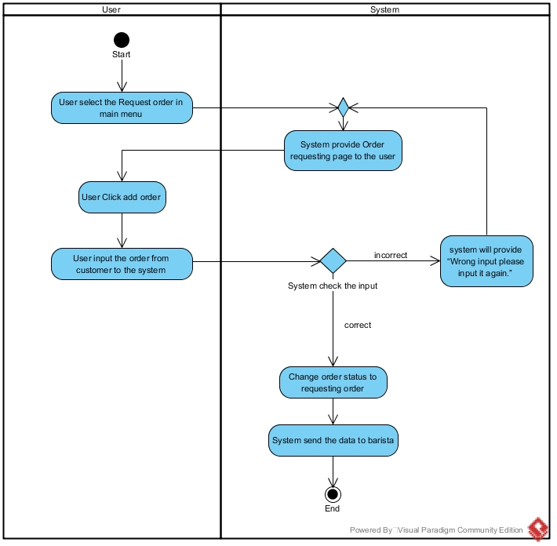

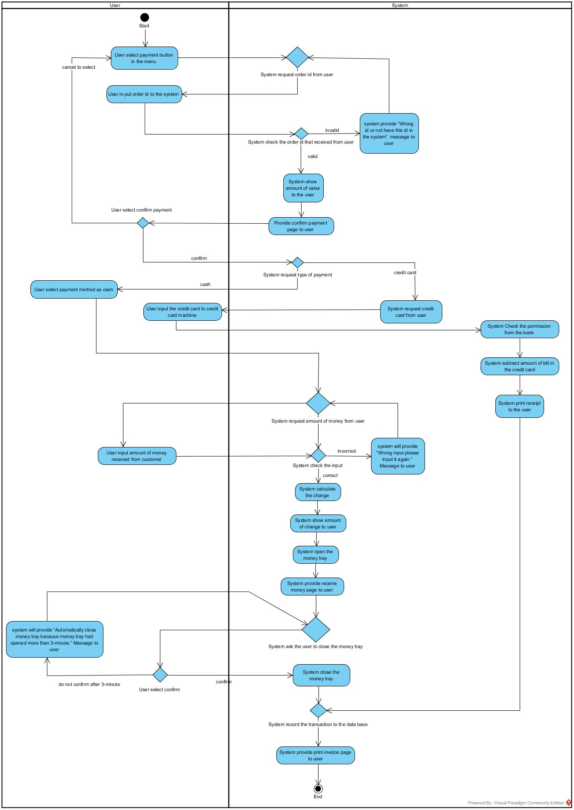AD-002 Payment

AD-003 Login

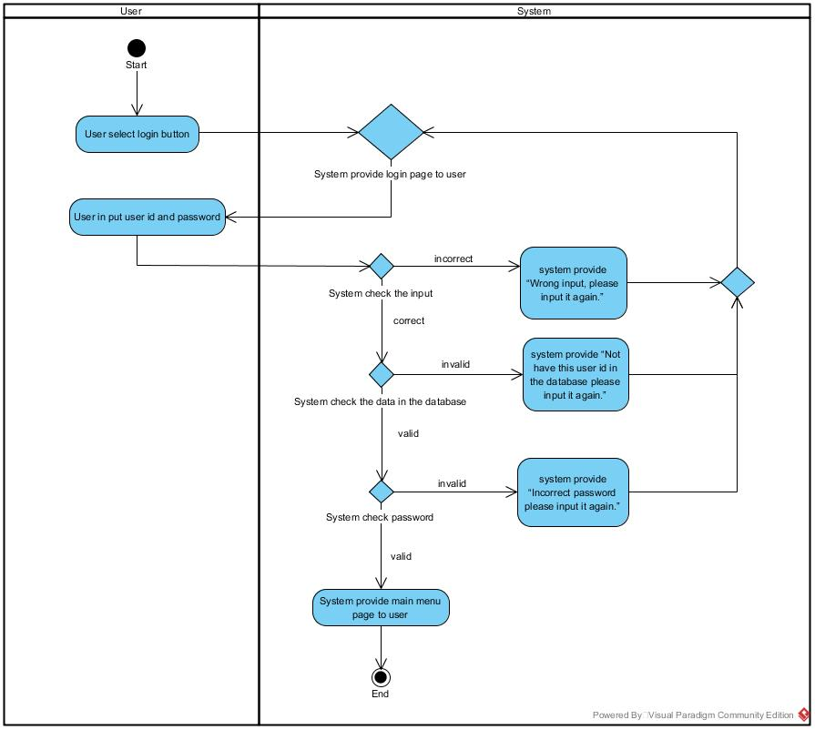

AD-004 Confirm order

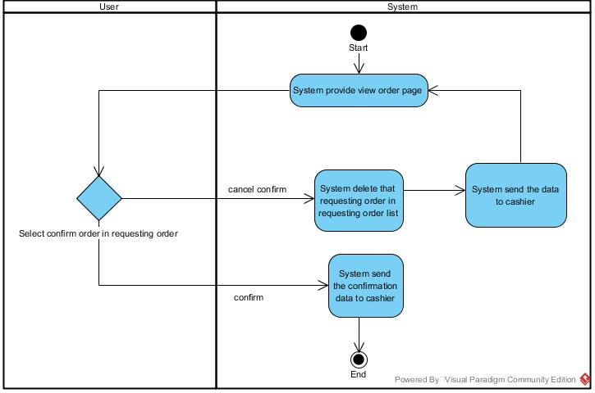

AD-005 Print invoice

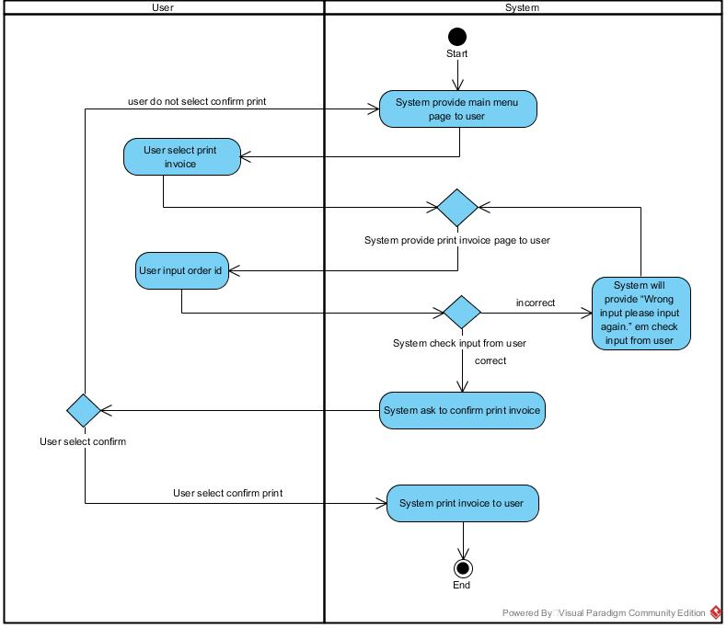

AD-006 Complete Order

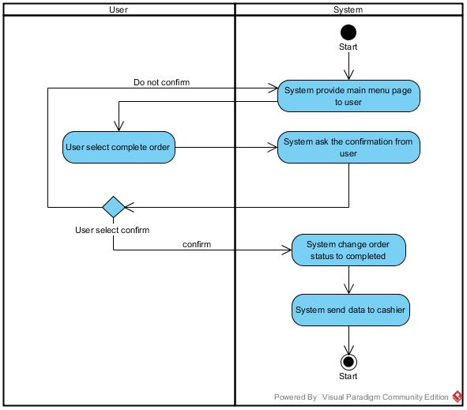

AD-007 View Order

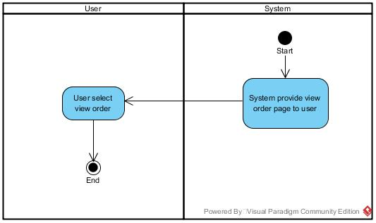

AD-008 View Summary

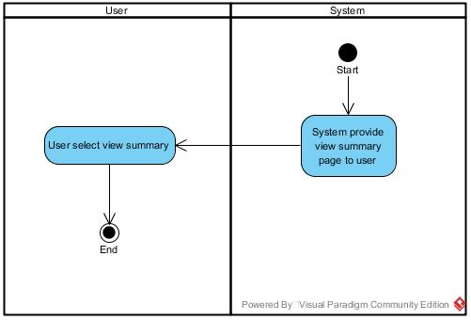

AD-009 Add Cashier

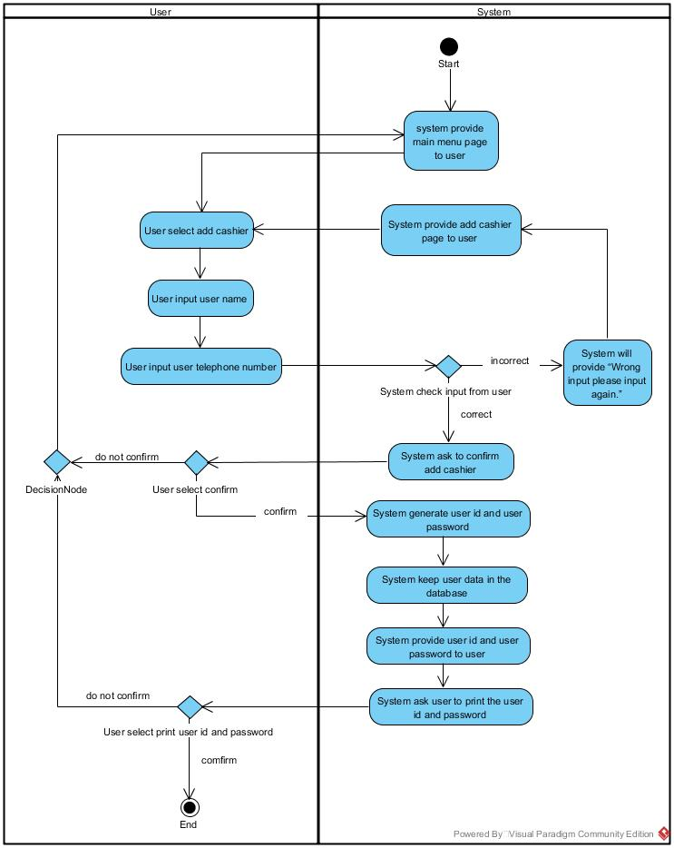

AD-010 Add Barista

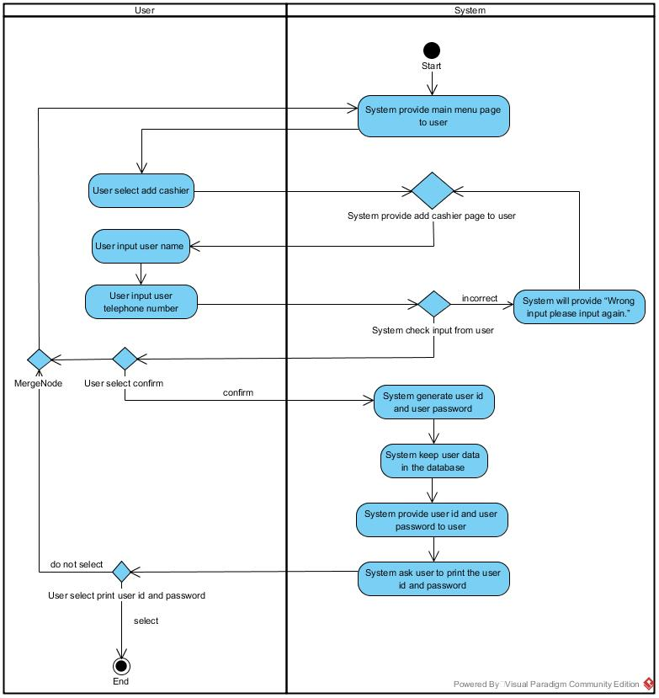

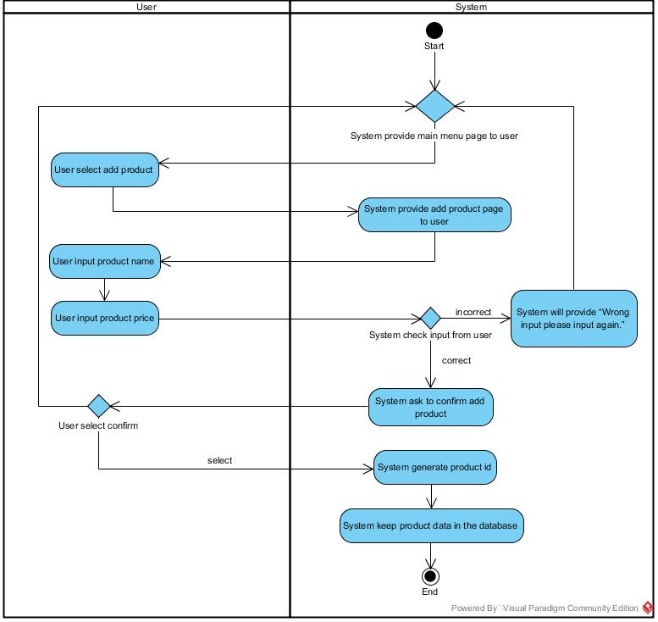AD-011 Add Product

AD-012 Delete Cashier

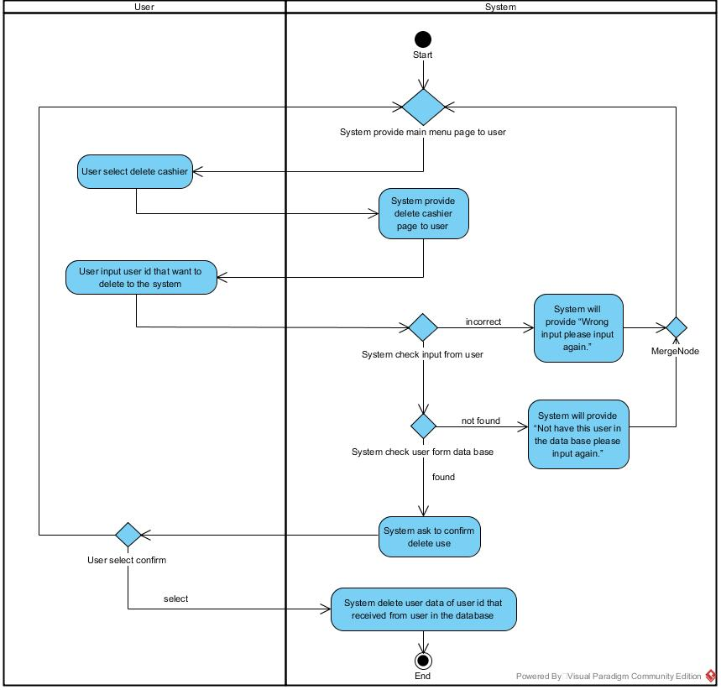

AD-013 Delete Barista

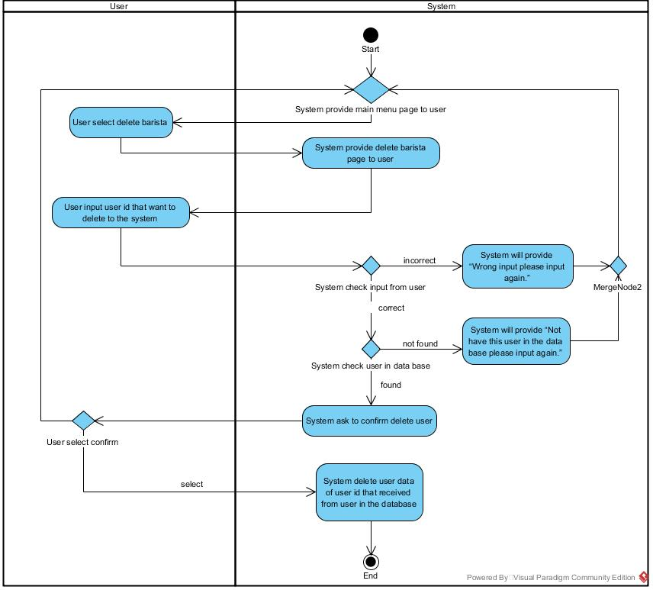

AD-014 Delete Product

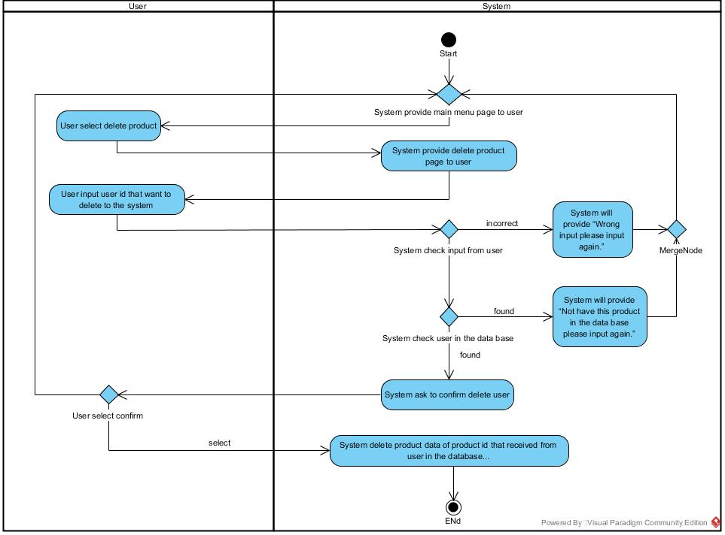

AD-015 Delete Order

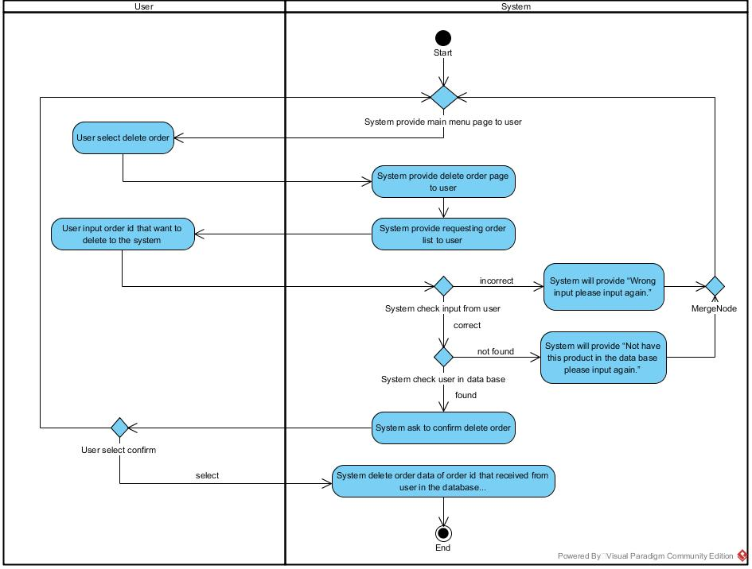

AD-016 Print Order ID

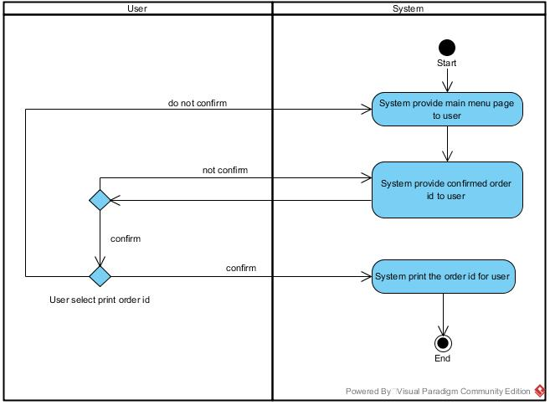

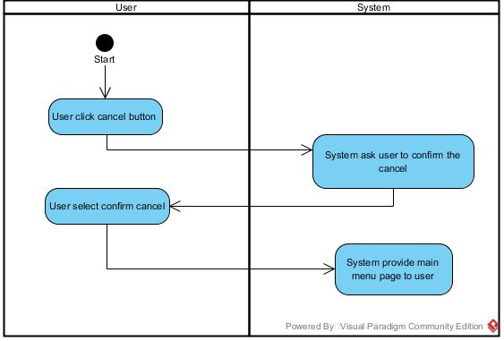AD-017 Cancel

AD-018 Logout

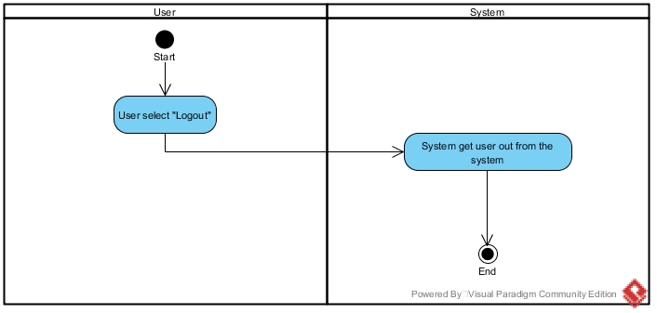

**Class Diagram**

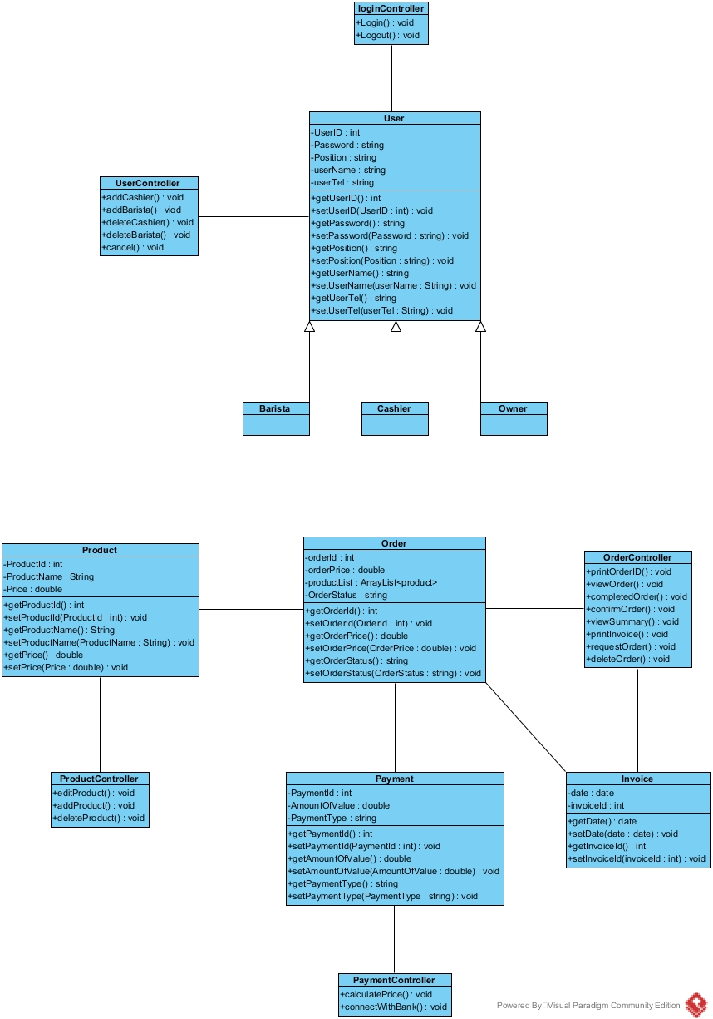

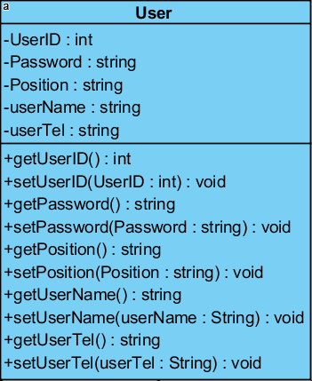**Class Description**- CD-01: User

Entities

|  |  |  |  |
| --- | --- | --- | --- |
| ID | Name | Description | Type |
| 1. | UserID | User in System Id number. | int |
| 2. | Password | Password User in System | string |
| 3. | Position | Position in system such as ,Cashier and Barista | string |
| 4. | userName | Username in System | string |
| 5. | userTel | Telephone number of user | string |

Method Detail

Method Name : getUserID():int  
Description : Get value of UserID  
Return : UserID Value  
  
Method Name : setUserID(UserID:int):void  
Description : Set a value of UserID   
Return : UserID Value

Method Name : getUPassword():string  
Description : get value of password  
Return : Password Value

Method Name : setUPassword(UPassword:string):void  
Description : set value of password  
Return : Password Value

Method Name : getPostition ():string  
Description : Get value of Position  
Return : Postition  
  
Method Name : setPostion(Postition:string):void  
Description : Set a value of Position  
Return : Position

Method Name : getUserName ():string  
Description : Get value of Username  
Return : UserName value  
  
Method Name : setUserName (UserName:string):void  
Description : Set a value of Username n  
Return : UserName value

Method Name : getUserTel ():string  
Description : Get value of Telephone number  
Return : UserTelvalue  
  
Method Name : setUserTel (UserTel:string):void  
Description : Set a value of Telephone number  
Return : UserTel value

CD-02: UserController

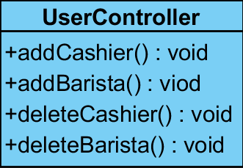

Method Detail

Method Name : addChashier() : void  
Description : Add cashier in to the system.  
Return : addChashier value

Method Name : addBarista() : void  
Description : Add barista to the system.  
Return : addBarista value

Method Name : deleteChashier() : void  
Description : Delete chashier in to the system.  
Return : deleteChashier value

Method Name : deleteBarista() : void   
Description : Delete Barista in to the system.  
Return : deleteBarista value

CD-03: Owner

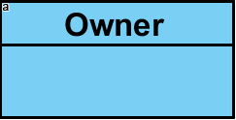

Method Detail

Extends from class User.

CD-04: Cashier

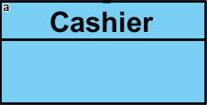

Method Detail

Extends from class User.

CD-05: Barista

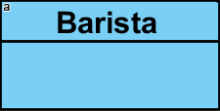

Method Detail

Extends from class User

CD-06: Order

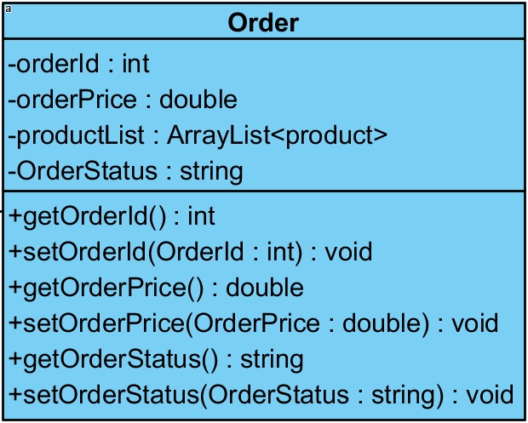

Entities

|  |  |  |  |
| --- | --- | --- | --- |
| ID | Name | Description | Type |
| 1. | orderId | Number of order for identity order. | int |
| 2. | orderPrice | Price of order | double |
| 3. | productList | List of product for identity new product object from ProductClass | ArrayList |
| 4. | OrderStatus | Status about order such as, Requesting,  Doing and Completed | string |

Method Detail

Method Name : getorderId():int  
Description : Get value of orderId.  
Return : orderId

Method Name : setorderId(OrderID:int):void  
Description : Set value of orderId.  
Return : orderId

Method Name : getOrderPrice ():double  
Description : get value of OrderPrice.   
Return : OrderPrice

Method Name : setOrderPrice (PriceOrder:double):void   
Description : set value of OrderPrice.   
Return : OrderPrice

Method Name : getOrderStatus():string  
Description : get value of status of order.   
Return : OrderStatus

Method Name : setOrderStatus(OrderStatus:string):void  
Description : set value of OrderStatus.   
Return : OrderStatus

CD-07: OrderController

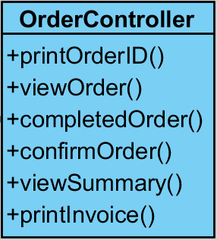

Method Detail

Method Name : printOrderID()  
Description : Print order id.  
Return : printOrderID value

Method Name : viewOrder()  
Description : View order.  
Return : Order value

Method Name : completedOrder ()  
Description : Completed order.  
Return : completedOrder value

Method Name : confirmOrder() : void   
Description : Confirm order.  
Return : confirmOrder value

Method Name : viewSummary() : void   
Description : View summary.  
Return : viewSummary value

Method Name : printInvoice() : void   
Description : Print invoice.  
Return : printInvoice value

CD-08: Product

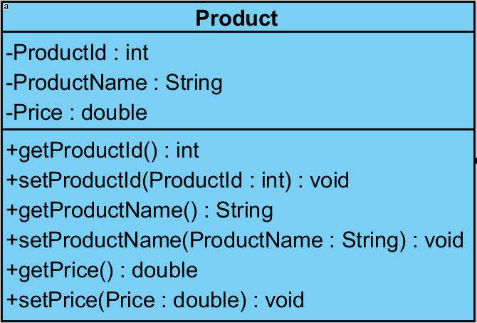

Entities

|  |  |  |  |
| --- | --- | --- | --- |
| ID | Name | Description | Type |
| 1. | ProductId | Number of product for identity product. | int |
| 2. | ProductName | Name of product | String |
| 3. | Price | Price of product | double |

Method Detail

Method Name : getProductId():int  
Description : Get value of ProductId.  
Return : ProductId

Method Name : setProductId (ProductId : int):void  
Description : set value of ProductId.  
Return : ProductId.

Method Name : getProductName():string  
Description : Get value of ProductName.  
Return : ProductName

Method Name : setProductName(ProductName:string):void  
Description : set value of ProductName.  
Return : ProductName

Method Name : getPrice() : double  
Description : get value of price.   
Return : Price

Method Name : setPrice(Price : double) : void  
Description : set value of price.   
Return : Price

CD-09: ProductController

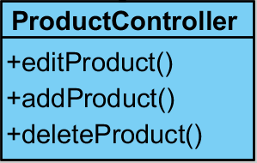

Method Detail

Method Name : editProduct()  
Description : Edit product.  
Return : editProduct value

Method Name : addProduct()  
Description : Add product.  
Return : addProduct

Method Name : deleteProduct()  
Description : Delete product.  
Return : deleteProduct value

CD-010: Payment

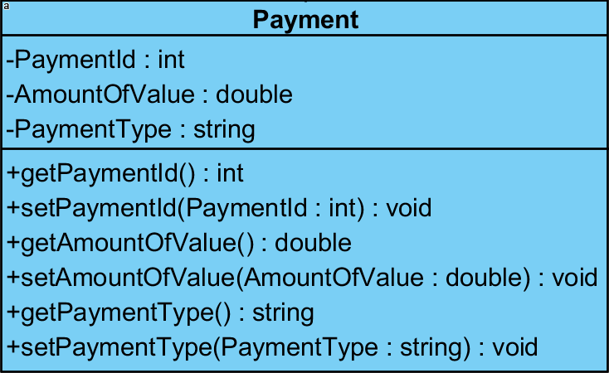

Entities

|  |  |  |  |
| --- | --- | --- | --- |
| ID | Name | Description | Type |
| 1. | PaymentId | Number of payment for identity payment | int |
| 3. | AmountOfValue | Show amout of value | Double |
| 4. | PaymentType | Type of payment suchas,Cash or CreditCard | string |

Method Detail

Method Name : getPaymentID():int  
Description : Get value of PaymentId.  
Return : PaymentID  
  
Method Name : setPaymentID(PaymentID:int):void  
Description : Set value of PaymentId.  
Return : PaymentID

Method Name : getAmountOfValue ():double  
Description : Get value of Amount of value.  
Return : amount of value

Method Name : setAmountOfValue (AmountOfValue:double):void  
Description : Set value of Amount of value.  
Return : amount of value

Method Name : getPaymentType ():string  
Description : Get value of Amount of value.  
Return : payment type  
  
Method Name : setPaymentType (PaymentType:string):void  
Description : Set value of Amount of value.  
Return : payment type

CD-11: ProductController

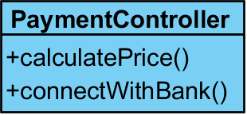

Method Detail

Method Name : calculatePrice()  
Description : Calculate price.  
Return : calculatePrice value

Method Name : connectWithBank ()  
Description : Connect with the bank.  
Return : connectWithBank

CD-12: LoginController

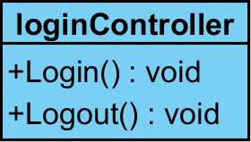

Method Detail

Method Name : Login() : void  
Description : Login to the system.  
Return : Login value

Method Name : Logout () : void  
Description : Logout to the system.  
Return : Logout value

CD-12: invoice

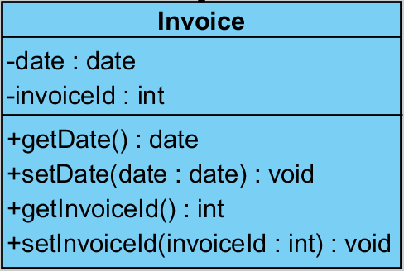

Entities

|  |  |  |  |
| --- | --- | --- | --- |
| ID | Name | Description | Type |
| 1. | date | Date of invoice. | date |
| 2. | invoiceId | Number of invoice for identity product. | int |

Method Detail

Method Name : getDate() : date  
Description : get value of Date.  
Return : Date

Method Name : getDate(date : date) : void  
Description : set value of Date.  
Return : Date

Method Name : getinvoiceId ()  
Description : get value of invoiceId.  
Return : invoiceId

Method Name : setinvoiceId ()  
Description : set value of invoiceId.  
Return : invoiceId

**Sequence Diagram**

SD-001 Request Order

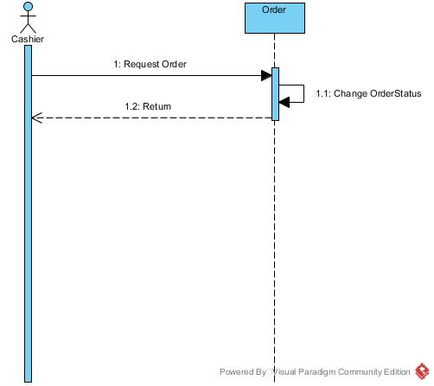

SD-002 Payment

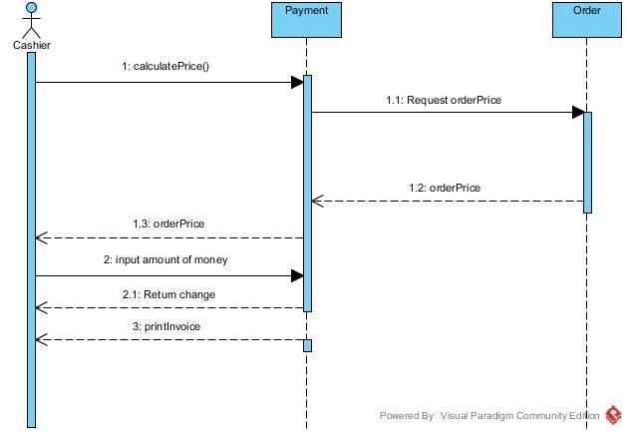

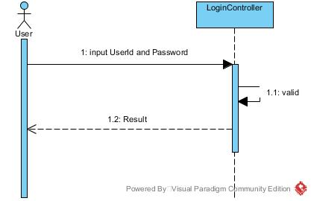SD-003 Login

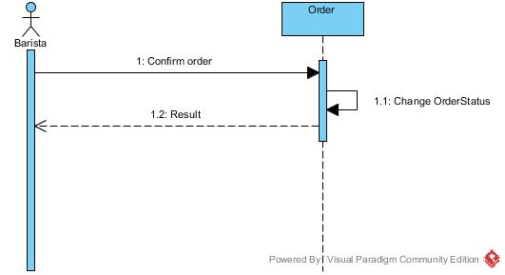SD-004 Confirm order

SD-005 Print invoice

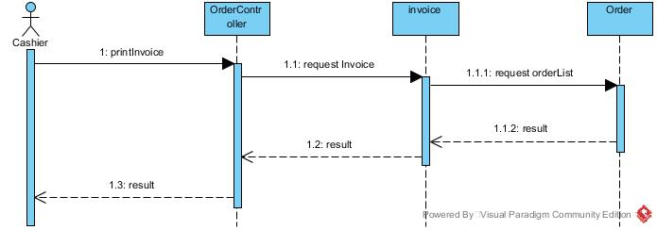

SD-006 Complete Order

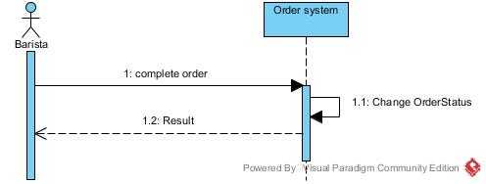

SD-007 View Order

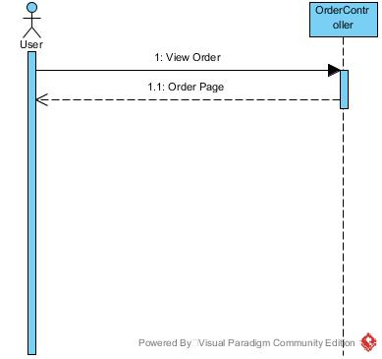

SD-008 View Summary

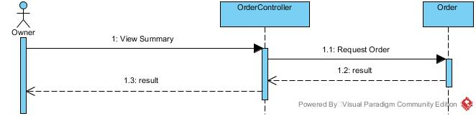

SD-009 Add Cashier

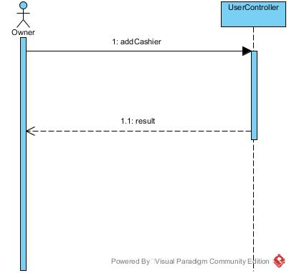

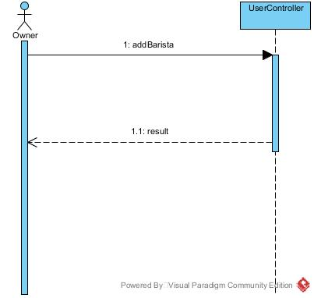SD-010 Add Barista

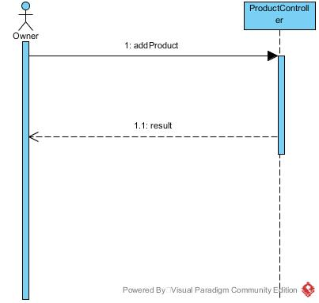SD-011 Add Product

SD-012 Delete Cashier

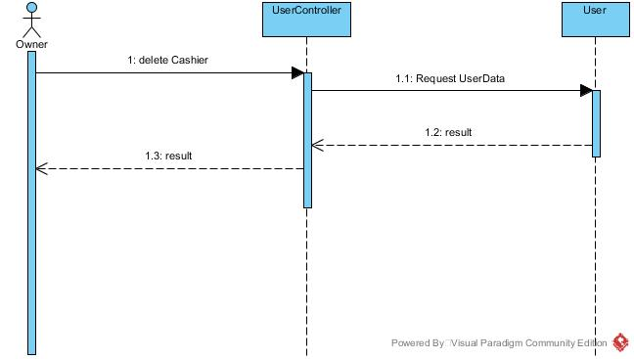

SD-013 Delete Barista

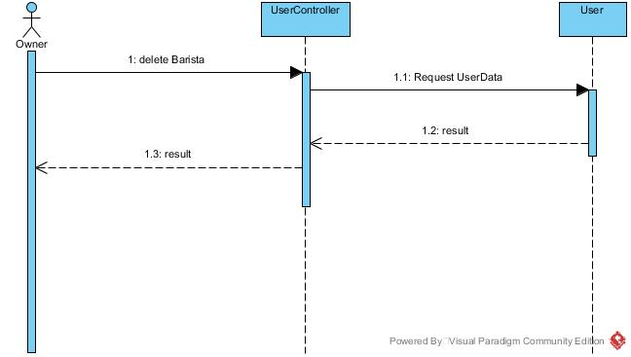

SD-014 Delete Product

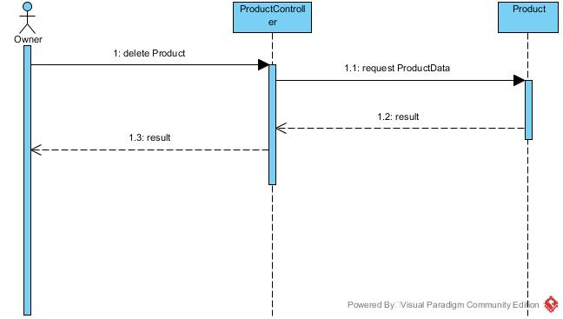

SD-015 Delete Order

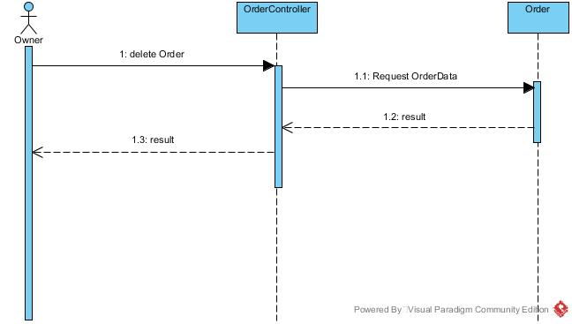

SD-016 Print Order ID

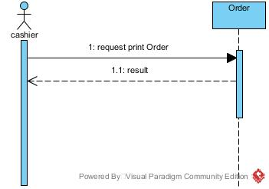

SD-017 Cancel

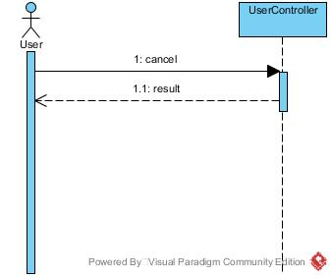

SD-018 Logout

